Pull The repo to the local

Steps:

- Install the git on the Local VM
- Pull the github repo to local using the https
- Check the commits

- Install the git on the Local VM
$ sudo apt install git -y
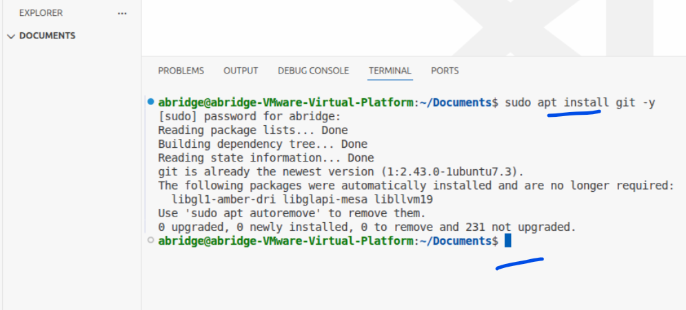
$ git –version
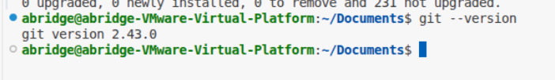

- Pull the github repo to local using the https

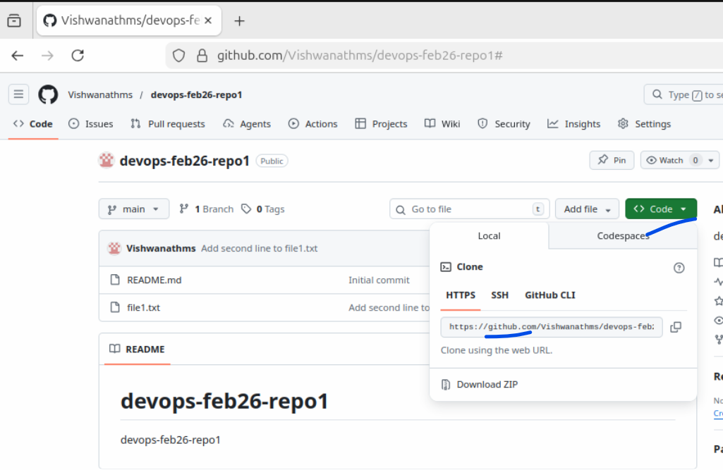

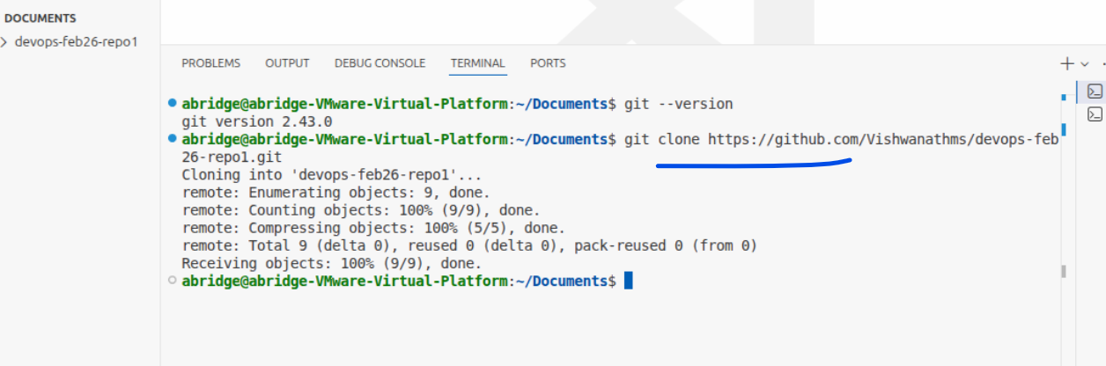
$ git clone https://github.com/Vishwanathms/devops-feb26-repo1.git

On the left had side the folder would be created with the repo name
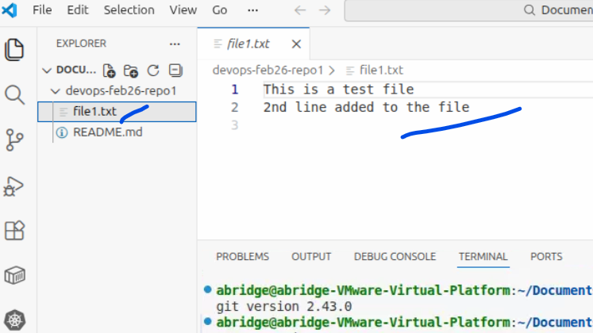

- Check the commits
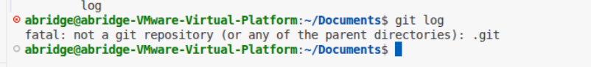
Move to the folder that is created
And then run
$ git log

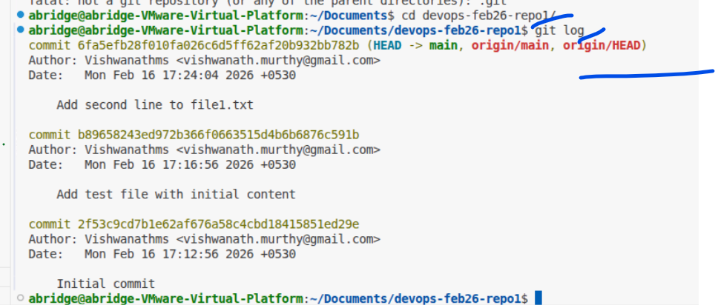

- Update the file and push it back to central repo
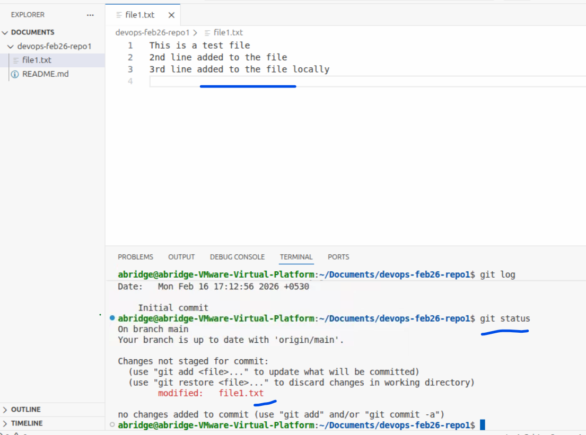
Added line 3 and run
$ git status
Now lets move to “Staged area”
$ git add .
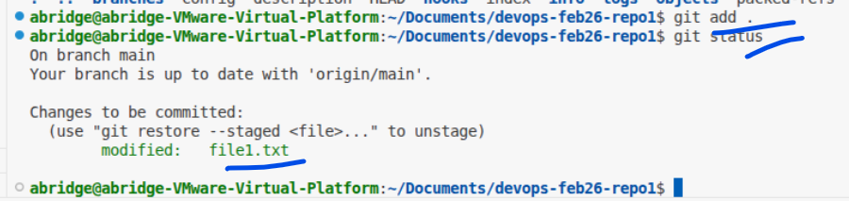

Now lets move it to local repo
$ git commit -m “added line3 in local”
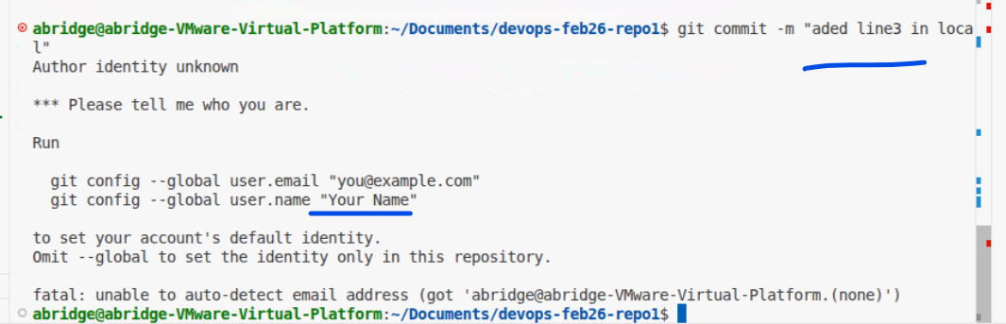

Means , we need to configure the email and name.

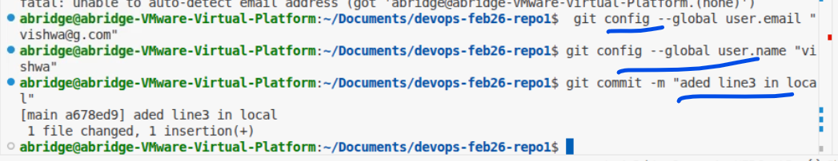
Run the below commands.

$ git config --global user.email vishwa@gmail.com
$ git config --global user.name “Vishwa”

- Check the log
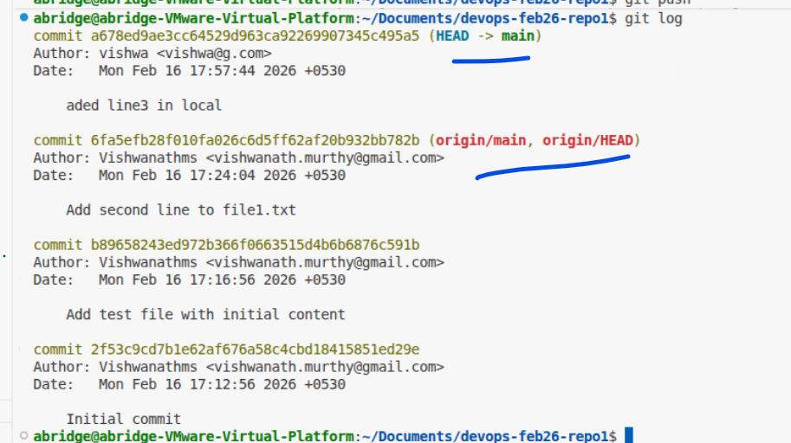
Here “origin/main” refers to remote.

- Do the git push and check the error
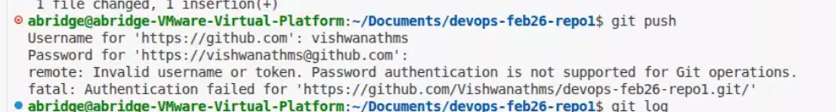

This is not a better way of pushing the code to the remote.

